**Lecture 01 (What is Node js)**

* Nodejs allows us to use js outside the browser For Eg: creating a desktop application (Atom code editor was written in Node js) etc.
* It also allows js to run on servers.

**Lecture 04**

* Practice of using terminal for making folder etc.

**Lecture 05**

* Using the node command line to execute file and intro to REPL loop.

**Lecture 06 (How to use native node modules)**

* Intro to using native node modules such as File System.
* To add file system module you are gonna use the following line of code to include it in your code.



* You get access to the file system module using the require system from node.
* You can copy the contents of one file to another using the copyFileSync method, the first argument is the source, while the second argument is the destination.



**Lecture 07 (The npm package manager and installing external node modules)**

* Npm is a package manager for external modules that anybody can build and you can incorporate in your projects.
* Packages on npm are bits that somebody else wrote and using npm you can incorporate that code in your own projects.
* Npm is bundled with node so when you install node you install npm along with it.
* You can initialize npm by using npm init.
* Now you can select any module from npmjs.com and use it in your own project.
* Npm creates a package.json file that contains all the info about your project’s dependencies, like here our project has 1 dependency called superheroes.

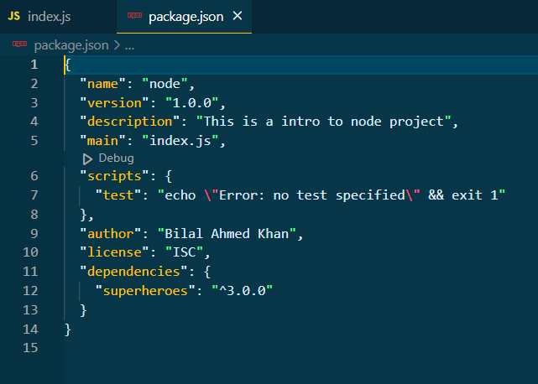

* All this info is packages inside json, json is a file format used to organize this data.